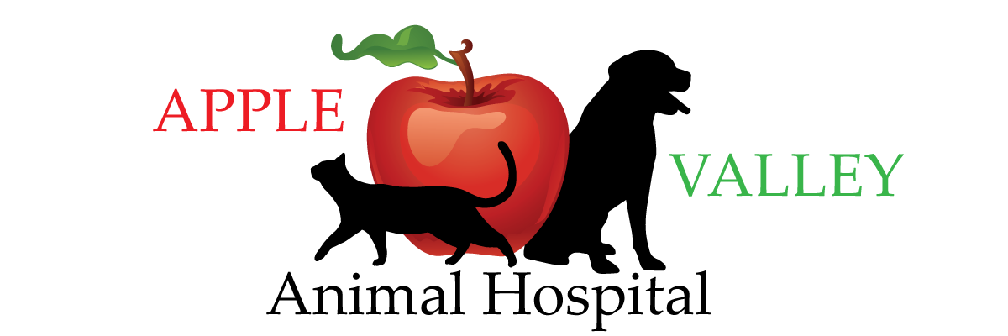
Apple Valley Animal Hospital
1207 Cedar Creek Grade
Winchester, Va 22602
540-678-0202 avahpets@gmail.com applevalleypet.com

If there is an unexpected or life-threatening situation involving any of my pets, I would like the following actions taken:

[ ] I give permisson for the doctors and support staff of the Apple Valley Animal Hospital to initiate life-saving emergency care and treatment for my pets. I understand that I am financially responsible for these treatments, and I am aware that intial stabilization fees could be up to $500.00.
After the initial stabilization, I will receive an estimate for the rest of my pet’s care.
I would like the following pets omited from this directive:

[ ] I do not wish for any heroic care to be performed on any of my pets without my permission and a written estimate. I understand in emergency situations time is of the essence, and by checking this box I will be delaying my pet’s care.

Client’s name _________________________________ Contact phone number _______________________________

In consideration for following my wishes, I hereby release the Apple Valley Animal Hospital, it’s staff and authorized representatives from any and all liablity that may have subsequently accrued to me, as a result of honoring this directive. I declare that the doctors and staff of the Apple Valley Animal Hospital are acting in accordance with my wishes.
I certify that I am the legal owner or the duly authorized agent for the owner of the pets listed on my record.
I understand that my wishes may be carried out immediately upon my signing this agreement. I assume full responsibility for applicable fees as listed above. I fully understand the foregoing provisions.
I understand that this advance directive will be honored until I wish to make changes to it.

Any decision I declare on the phone shall supersede my written directives.

Signature: ____________________________ Date: _______________
Witness: _____________________________

Winchester Animal Hospital
901 North Loudoun Street
Winchester, Va
540-667-0260
wahpets@gmail.com
winchesterpet.com

If there is an unexpected or life-threatening situation involving any of my pets, I would like the following actions taken:

[ ] I give permisson for the doctors and support staff of the Winchester Animal Hospital to initiate life-saving emergency care and treatment for my pets. I understand that I am financially responsible for these treatments, and I am aware that intial stabilization fees could be up to $500.00.
After the initial stabilization, I will receive an estimate for the rest of my pet’s care.
I would like the following pets omited from this directive:

[ ] I do not wish for any heroic care to be performed on any of my pets without my permission and a written estimate. I understand in emergency situations time is of the essence, and by checking this box I will be delaying my pet’s care.

Client’s name _________________________________ Contact phone number _______________________________

In consideration for following my wishes, I hereby release the Winchester Animal Hospital, it’s staff and authorized representatives from any and all liablity that may have subsequently accrued to me, as a result of honoring this directive. I declare that the doctors and staff of the Winchester Animal Hospital are acting in accordance with my wishes.
I certify that I am the legal owner or the duly authorized agent for the owner of the pets listed on my record.
I understand that my wishes may be carried out immediately upon my signing this agreement. I assume full responsibility for applicable fees as listed above. I fully understand the foregoing provisions.
I understand that this advance directive will be honored until I wish to make changes to it.

Any decision I declare on the phone shall supersede my written directives.

Signature: ____________________________ Date: _______________
Witness: _____________________________

